**The Serve**

The serve begins play and is the only skill completely within the control of an individual player. The serve is the only skill that can be duplicated without any adjustments in technique on all occasions. Successful serves can force opponents into difficult attack positions, reducing their attack options and enabling the serving team to react more effectively in setting up the defense. In addition, a server can score a point by serving the ball in such a way that the opponent is unable to return it. This is known as an ace. Types of serves vary and include the underhand serve, overhead float, jump serve, and standing spike. This handout will discuss the underhand serve and overhead float serve.

**GENERAL PRINCIPLES**

To ensure consistent service, the following steps should be followed:

1. Duplicate the same skill mechanics each time you serve.
2. The flight of the ball is determined by how close to the net and how high the ball is contacted.
3. Contact the ball with the "meat" part of the hand
4. Continue moving through the ball and toward the target after contact.

**The Overhead Float Serve**

The overhead float serve is designed to produce a "floating" ball that has no spin. Air currents, the ball not being perfectly round, the humidity, and the altitude can influence such a ball's path, making it its flight unpredictable. The floating serve's final destination is also unpredictable. The ball bobs, weaves, dips, rises, curves, and fades. In addition, the receiver has difficulty determining the speed of the serve because there is no spin to read.

**Preparation**

The server should take a position behind the serving line. The feet are spread apart with the foot on the same side as the shelf hand forward. The front leg should be flexed with 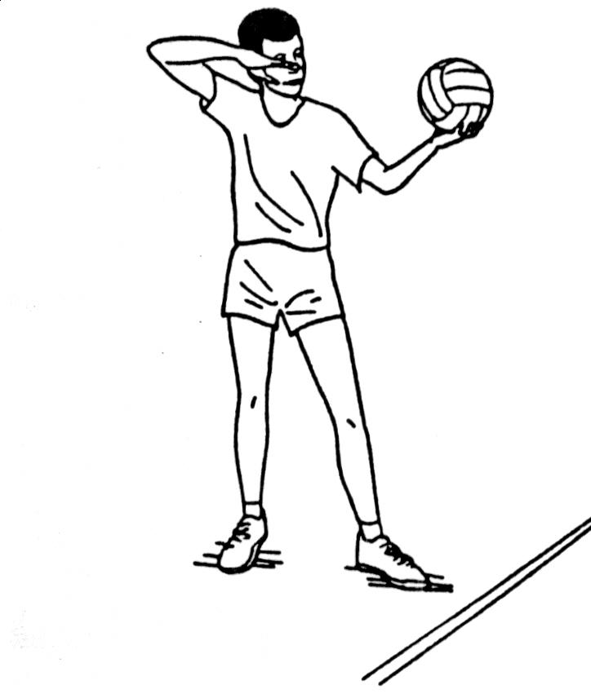the toe pointed toward the target. Most of the body weight is on the back leg. The shelf arm should be held comfortably flexed at a 90 degree angle at the elbow. The hand holding the ball should be at the player's neck level. The hitting arm should be positioned so that the elbow is as high and as far from the shoulder as possible. This position will reduce wind-up movements and insure consistent and high contact. The hitting hand should be in line with the lead toe and the wrist locked with the fingers pointing over the top of the ball at the target (Figure 2-4.)

**Precontact Movement**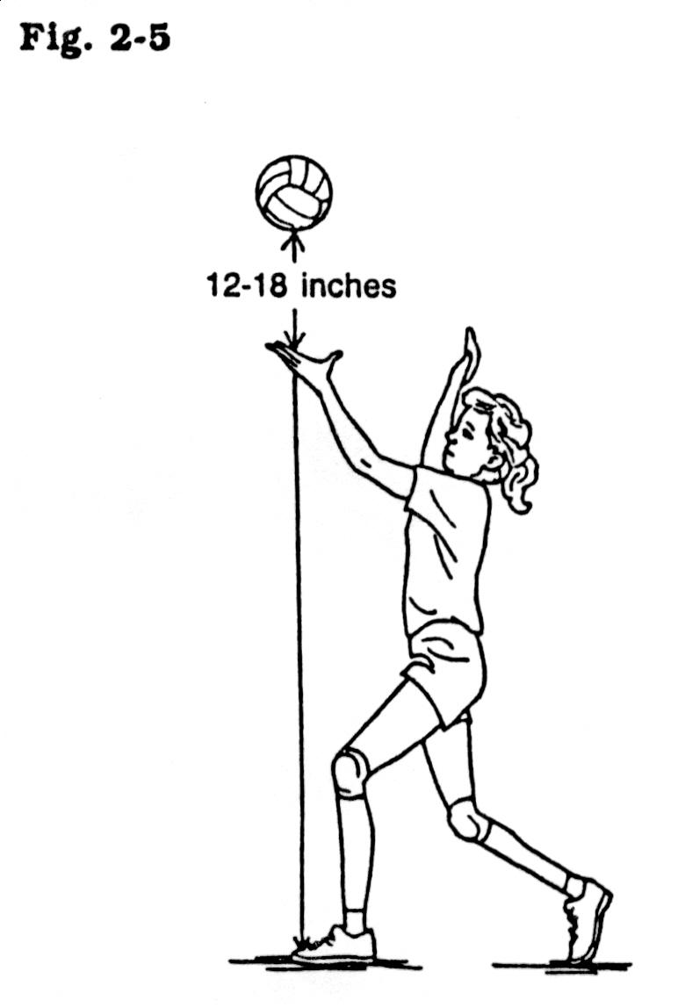

The serving motion has a two-count rhythm begun by the hitting arm being drawn back, the toss, and the lead foot stepping forward. On the count of two, the weight is transferred, and the ball is contacted. The toss is the key to a successful serve. During the toss, the ball should never be more than 12 to 18 inches above the shelf hand. With a well executed toss, the ball will have no spin and if the ball were to drop to the floor after the toss, it should land directly on or slightly in front of the lead toe (Figure 2-5.)

**Contact**

On the second count of the serving rhythm, the player should transfer weight from the back foot to the lead foot. The back foot drags on the toes and does not pass the lead foot. This allows for body stability and insures that the force of contact is directed at the selected target. The hitting arm's forward motion is begun with the shoulder and elbow. By leading with the shoulder and elbow, the player propels the hand forward in a whipping motion. The hitting hand remains locked at the wrist and is extended to contact the ball as high and as far in front of the head as possible. Contact is again made with the meat part of the hand. The hitting arm accelerates throughout the swing with the greatest forward motion occurring 6-8 inches prior to contact of the ball. You can tell how the ball was hit by watching the spin produced. If the ball spins to the left, contact was made on the right side of the ball; if the ball spins to the right, contact was made on the left side of the ball. Backspin indicates contact under the ball with a flexed wrist; topspin indicates contact over the top of the ball allowing the wrist to break. No spin means the ball was contacted dead center. Figure 2-7 illustrates these situations.

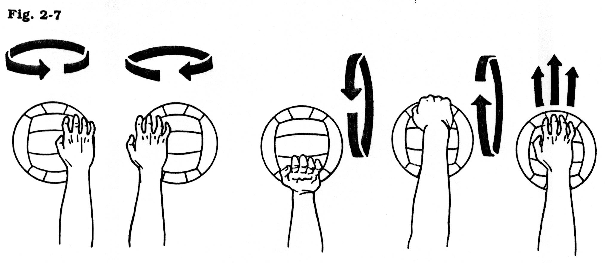

**Coaching Points**

1. The lead leg should be comfortable with the toe directed at the target.

2. The hitting arm should be drawn back with the elbow at shoulder level or higher.

3. The hitting hand should be locked at the wrist.

4. Players should hit through the ball with the meat part of the hand.

5. Greatest acceleration of the contact hand should occur just prior to contact on the ball.

**Tactical Applications**

The first and foremost application of the serve is to get the ball into the opponent's court. There are no tactics, nor is there play, if the serve is into the net or out of bounds. Once a player can consistently serve into the opponent's court, she should begin to vary the flight, velocity, and target of the serve. Consistent serving means that the player is able to place the served ball into the opponent's court with confidence and control 80% of the time.

**Varying Trajectory**

The server should be able to control the flight of the ball. The most effective servers use a variety of trajectories ranging from flat serves to lobs. This allows for flexible targeting. The trajectory can be varied by changing the distance behind the endline from which the player contacts the ball, or the height of the ball at contact. Such variation, coupled with a change in velocity, can increase the difficulty in the ability of the opponent's ability to receive the serve.

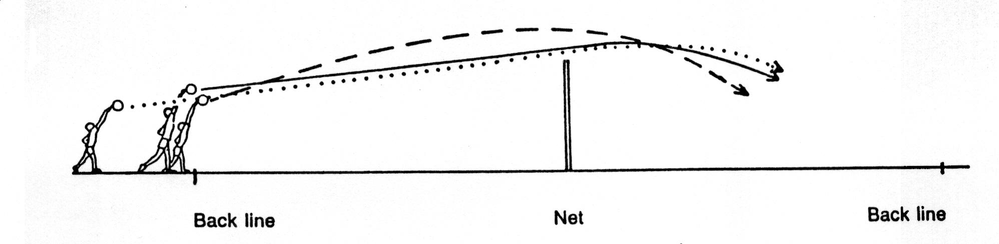

**Varying Velocity**

The server must learn to harness the force that controls the speed of the serve. Each player must learn (through experimentation) how much energy is required to get the ball to the intended target. The accomplished server will mask the amount of force used by appearing to use a particular motion, but increasing or decreasing acceleration just prior to contact of the ball.

**Varying Targets**

It is important that servers learn to place their serves to a variety of locations on the court. No seam of the opponent's alignment or corner of the opponent's court should be immune to a server's aim.

**Varying Techniques**

Ideally, as the player develops her skill in volleyball, she should develop several types of serves. At the beginning level, players should develop the underhand serve, the sidearm serve, and the overhand serve well enough to use in competition.

Serving is a weapon. It is one of the four ways of scoring in volleyball.

**Serving Locations**

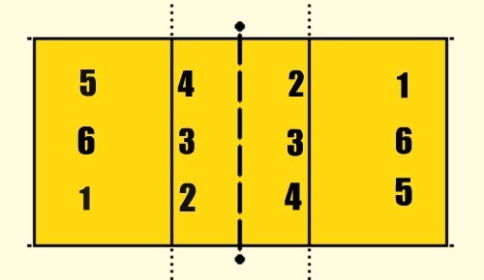

**Jump Serving**

Teaching Keys

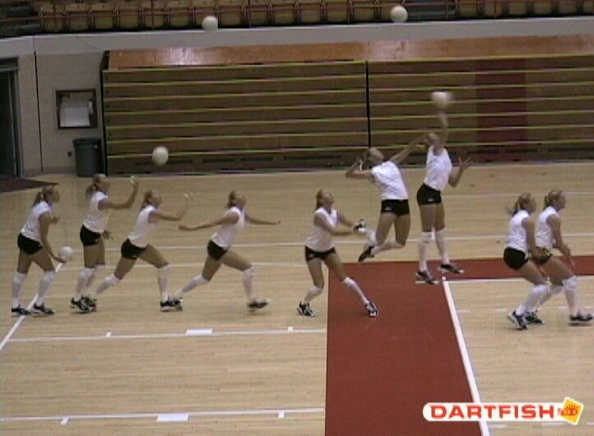

If you are new to jump serving you may wish to start with “slide jump serve”. A slide jump serve differs from a jump serve in that you approach along the base line and toss the ball with the opposite hand.

Example of a “slide jump serve”:

<http://www.teamusa.org/usa-volleyball/video/2013/12/13/usav-skill-video-slide-jump-serve?channel=AxaDRnazoIZ1U8fo-4cLMzn4EDvtFICe>

Examples of jump serve and float jump serve:

<https://www.youtube.com/watch?v=q6HWFfoVkm8>

<https://www.youtube.com/watch?v=yCzBPjWf3RQ>

1.**Right Hand, Right Foot** – (opposite for lefties)

The server starts with the ball in their right hand and steps with their right foot.

2. **4 Steps – Step, Toss, Step, Step, Step HIT** (HIGH TOSS)

The server takes a small step and then tosses, then finishes the rest of their 4 step approach

3. **Small, Bigger, Biggest/ Slow, Faster, Fastest**

The server can create momentum by the size and speed of their steps.

4. **Arms down, back and up**

Simple movements are better than complex ones. We want to create simple, efficient movements for effective serving. Also easy to repeat patterns that will hold up under pressure.

5.**Torque**

Stay tall and swing the “T” - toss has to be on right should – avoid pike. Players should remain tall, in an upright position.

